**1.3.3:**

**Does your university as a body provide support (e.g. food, housing, transportation, legal services) for students from low income families to enable them to complete university?**

**A N S W E R:**

The University of AlKafeel is dedicated to supporting students from low-income families by providing a range of services aimed at ensuring they can complete their education successfully, despite financial challenges.

### Academic and Career Support

The university offers free academic advising and tutoring services, which help students navigate their coursework, improve their academic performance, and maintain good grades. Additionally, career counseling and job placement assistance are provided to prepare students for employment after graduation.

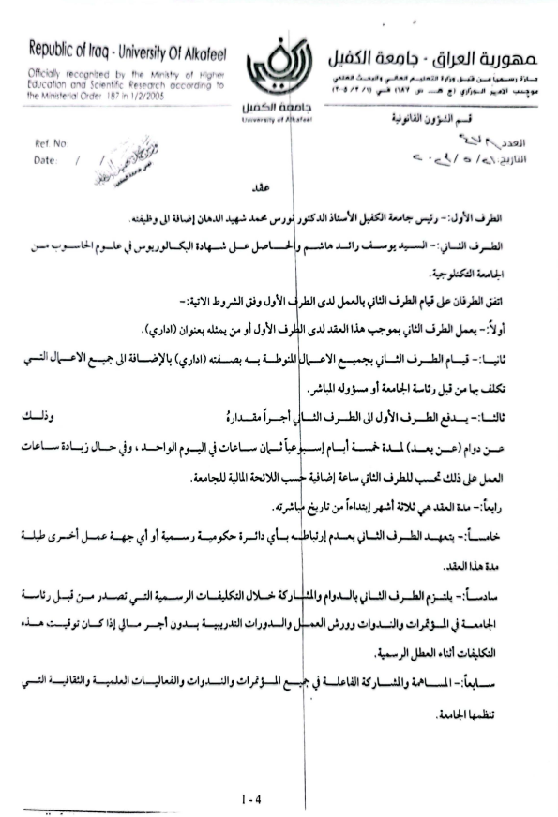

* **Providing remote job opportunities**
* **Our Job Portal**

We have developed a dedicated job platform to connect graduates with career opportunities and provide ongoing support after graduation. Our goal is to empower graduates by advertising job openings and this is the link to it

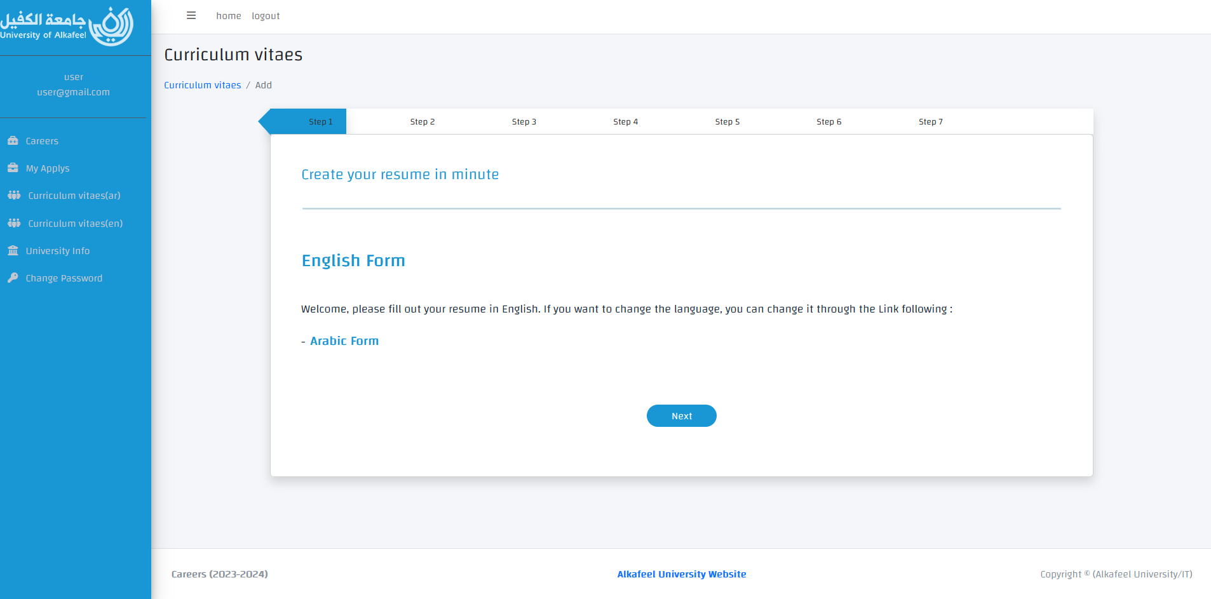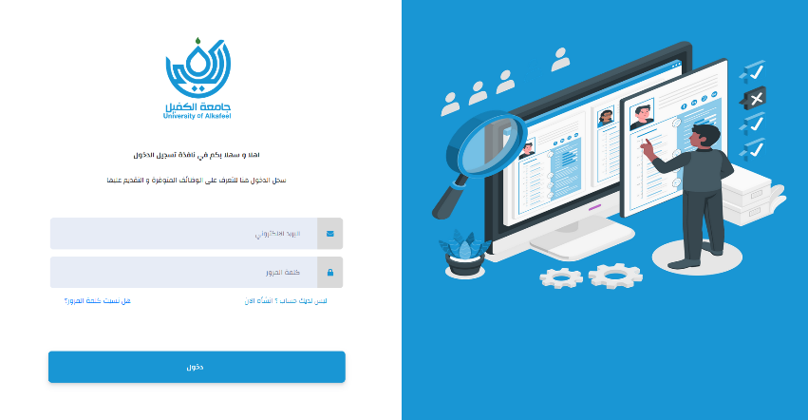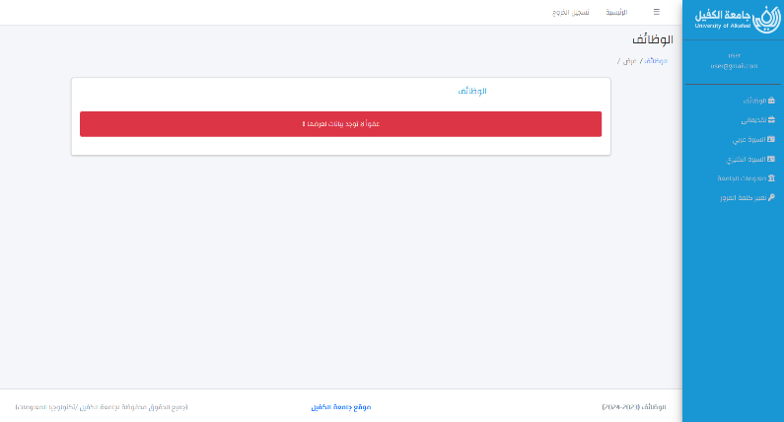<https://alkafeel.edu.iq/careers/user/login>

Careers Website

**Closing of the second job fair activities at Alkafeel University**

**Link:** <https://en.alkafeel.edu.iq/news/details/1513>



<https://youtu.be/PfflsFPVfQU>

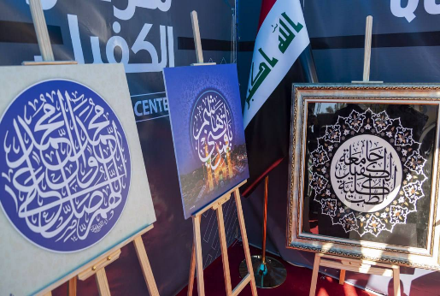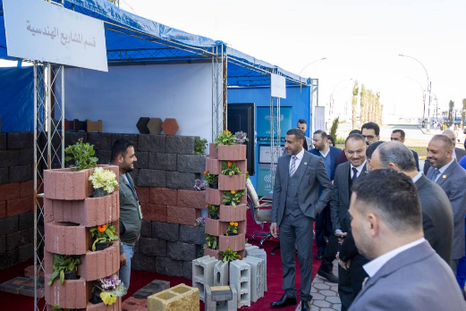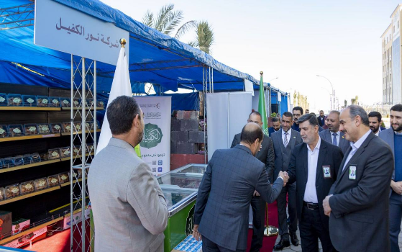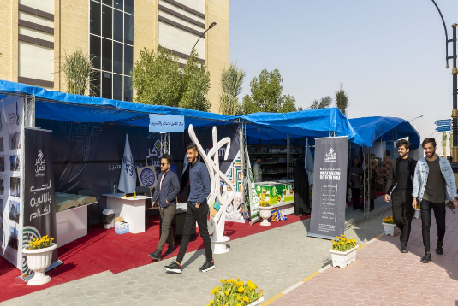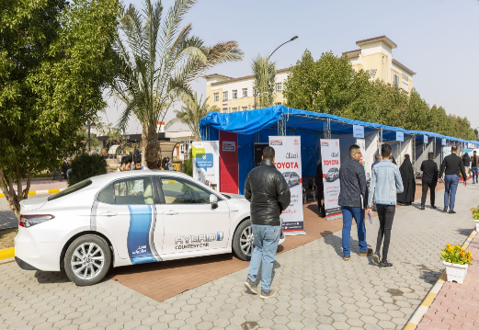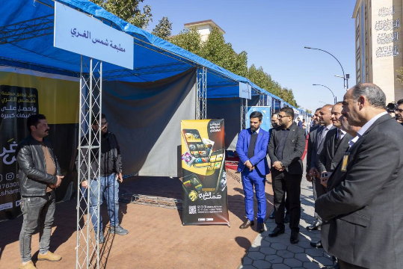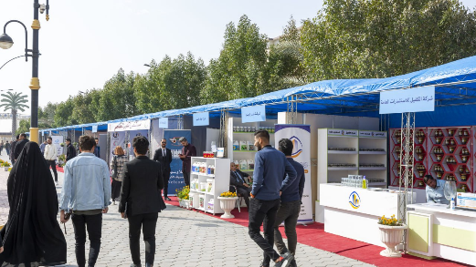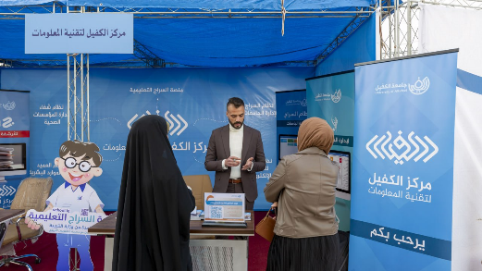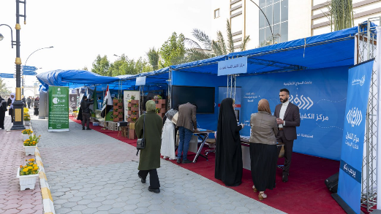

Job Fair - Day 3 2023/2/20

* 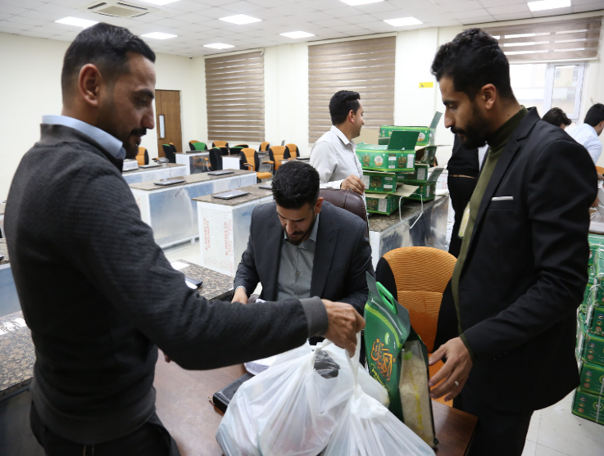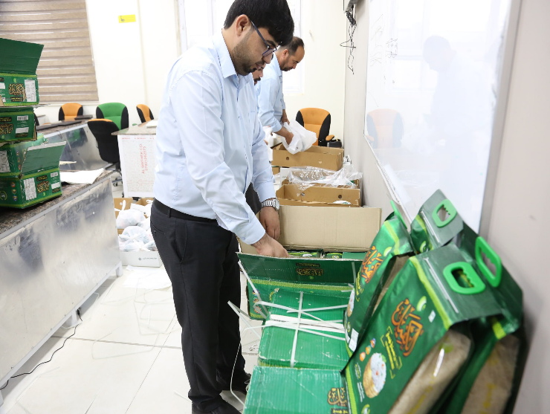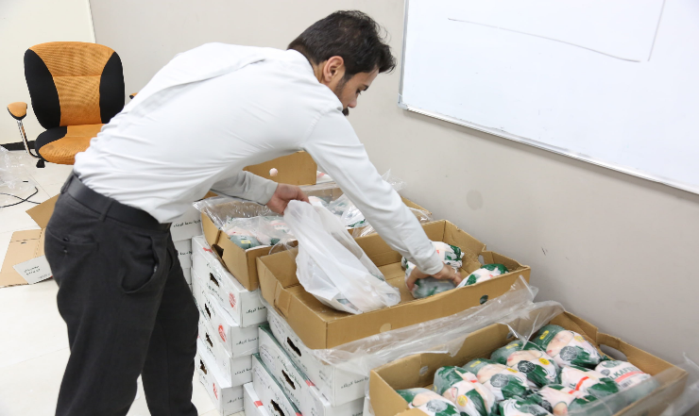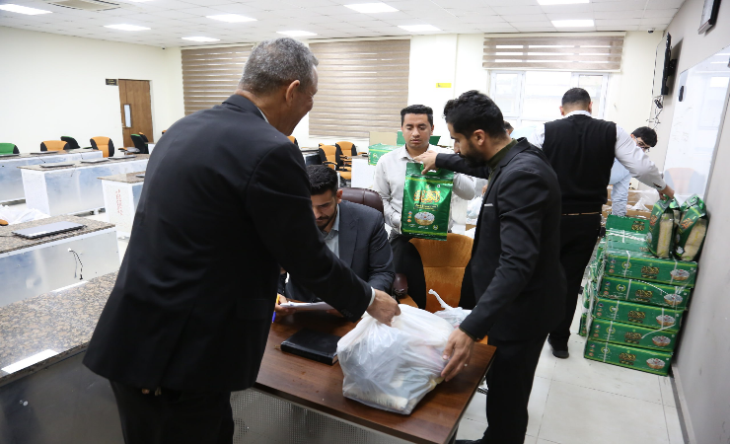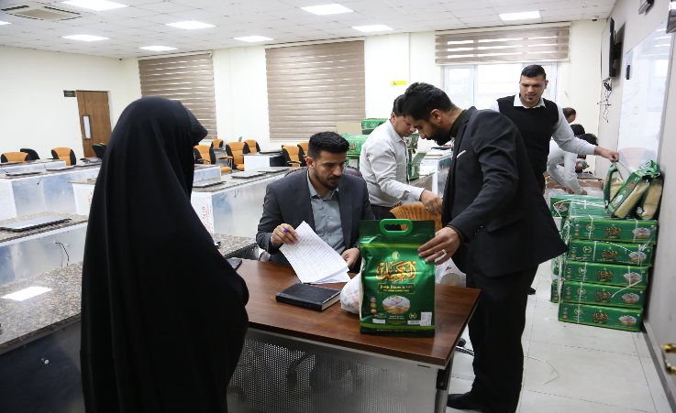**The Ramadan basket**

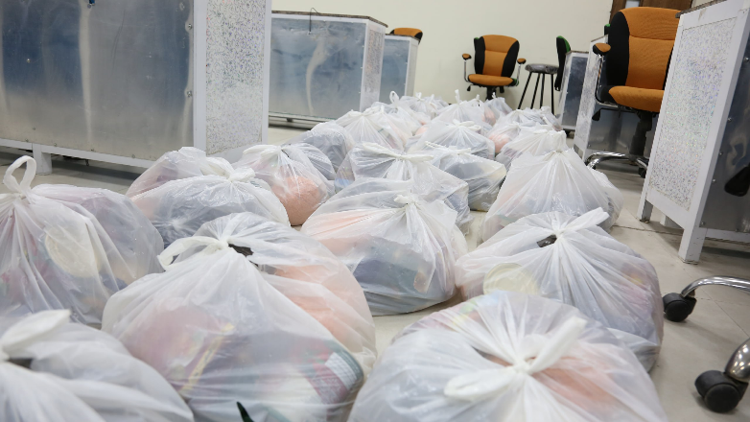

* 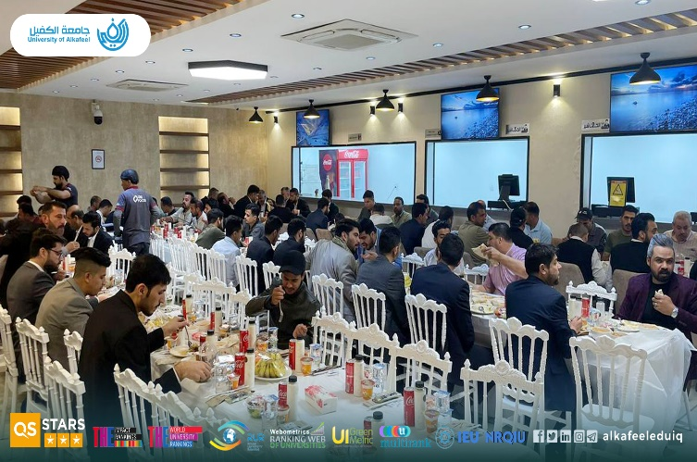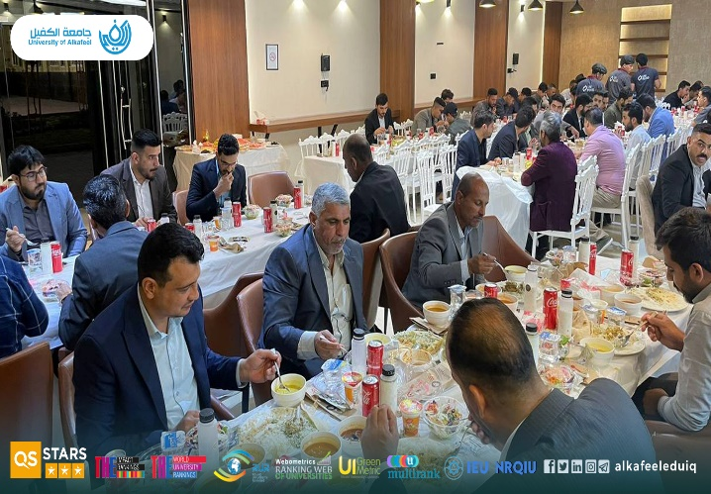Alkafeel University Enhances Social Solidarity by Distributing Food Baskets

**Link:** [**https://en.alkafeel.edu.iq/news/details/3451**](https://en.alkafeel.edu.iq/news/details/3451)

* University Club

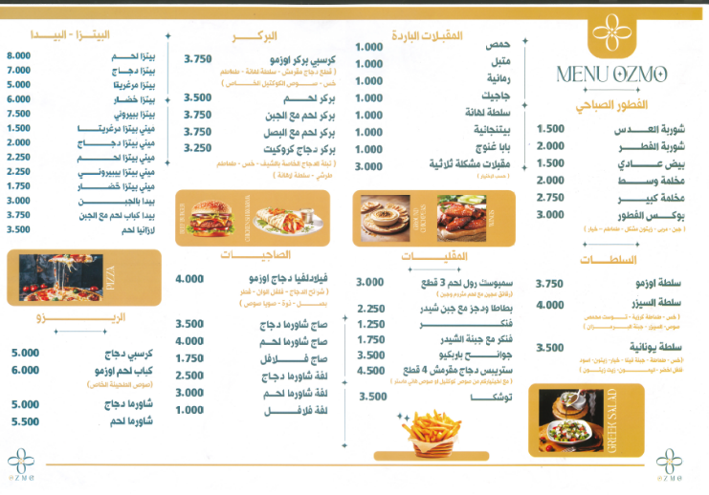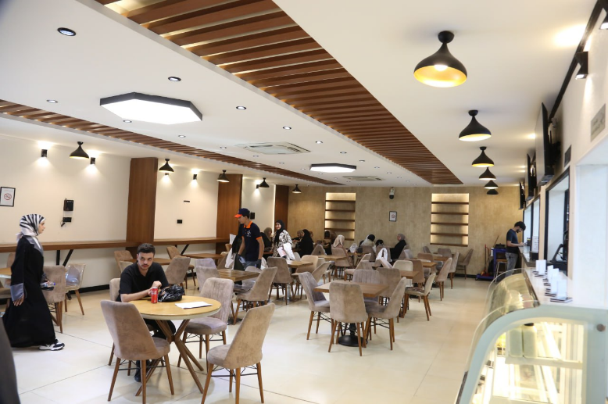

### 

### Financial Aid and Counseling

The university provides comprehensive financial aid counseling to help students from low-income backgrounds navigate the financial aid process. Through this counseling, students can apply for various financial aid programs, including grants and work-study opportunities, which help minimize educational costs.

Last year, the university launched the "Study in Iraq" scholarship program, which offered full coverage of tuition fees and living expenses for students from countries facing significant challenges, such as Yemen, Syria, and Lebanon. More than X students were admitted through this initiative, benefiting from the university's commitment to making higher education accessible to everyone, regardless of their financial situation.

The Student Support Committee, consisting of five dedicated members, evaluates each case on an individual basis, ensuring that assistance is granted to those who are in dire need. Over the past year, the committee successfully

**<https://studyiniraq.scrd-gate.gov.iq/home>**

**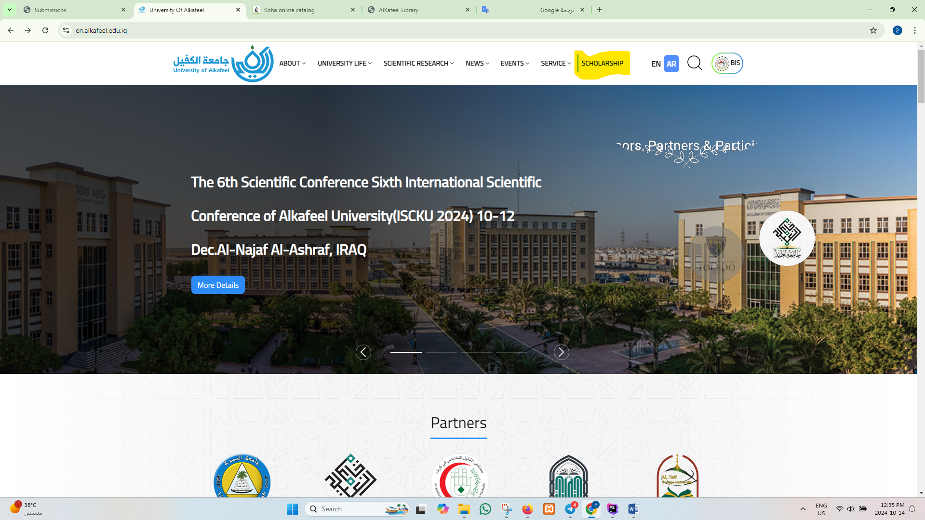**

processed X applications, providing financial aid, housing support, and academic resources to help students complete their studies.

And these are some official documents for the discounts:

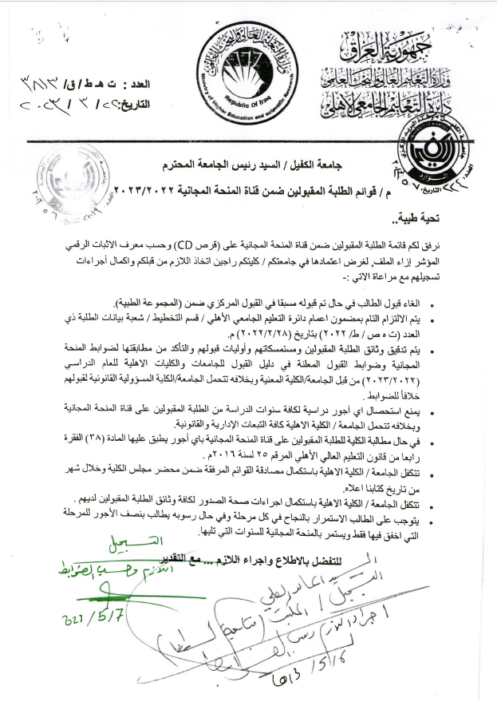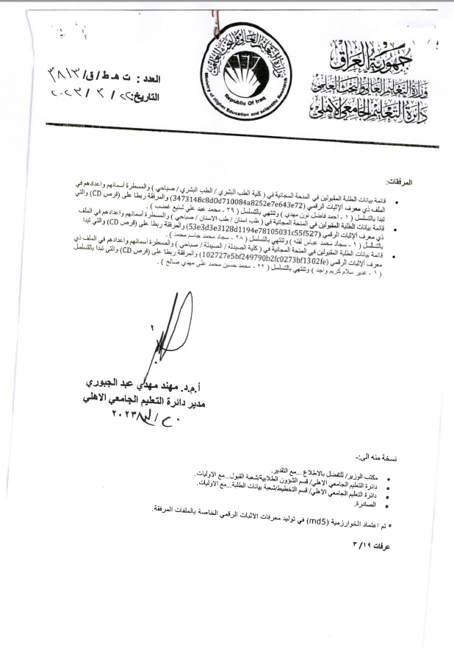

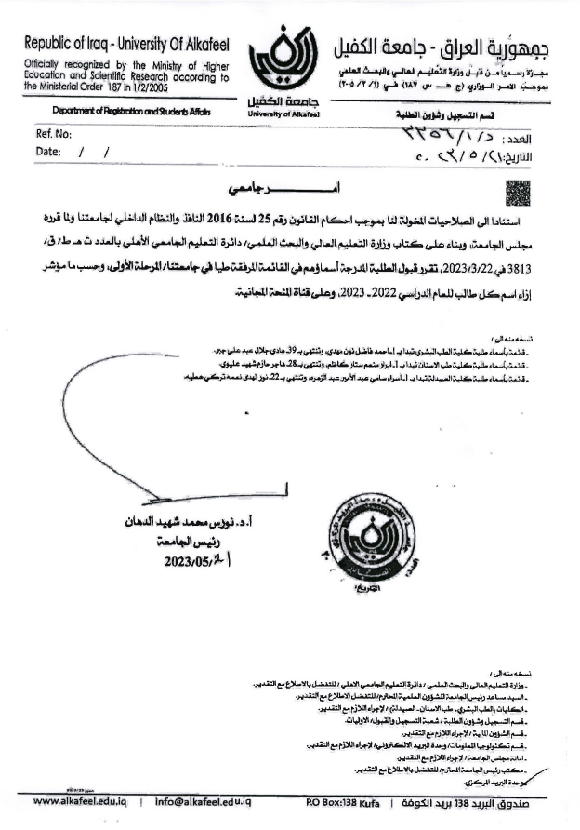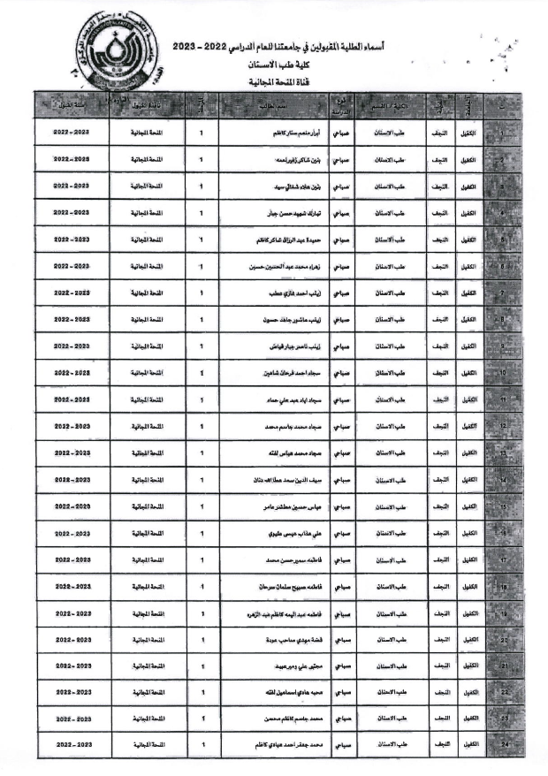

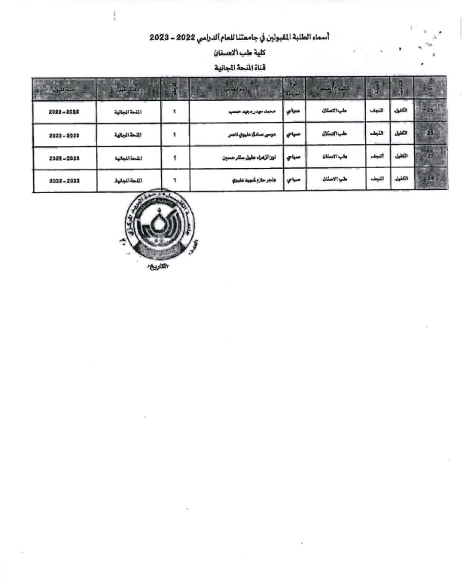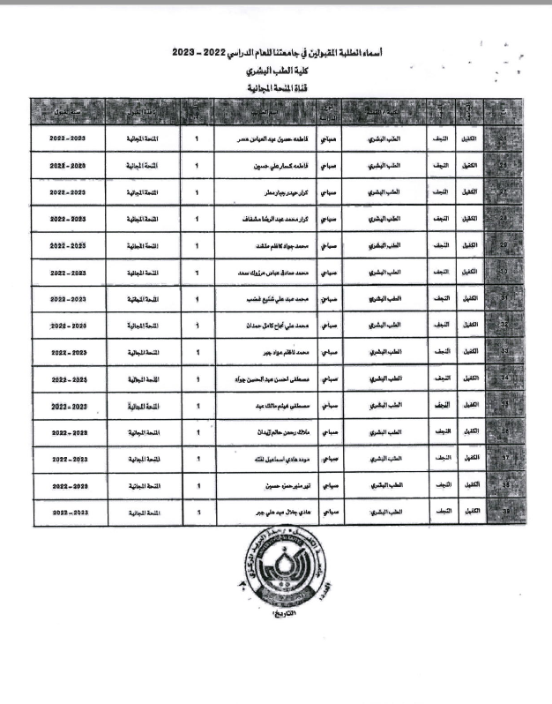

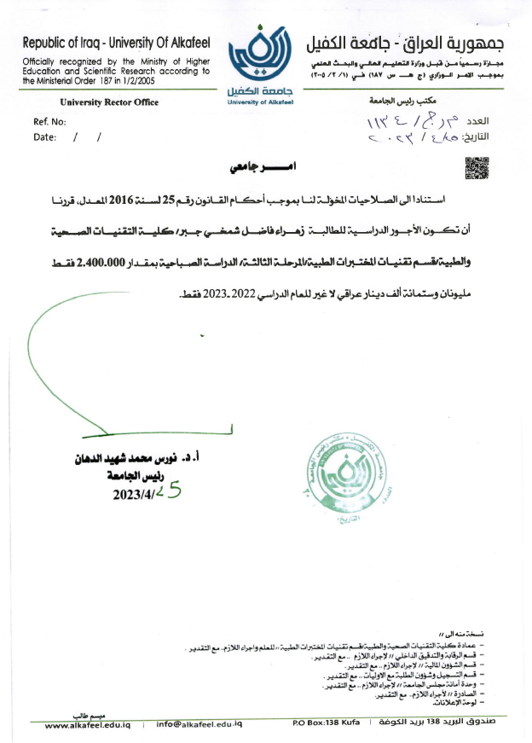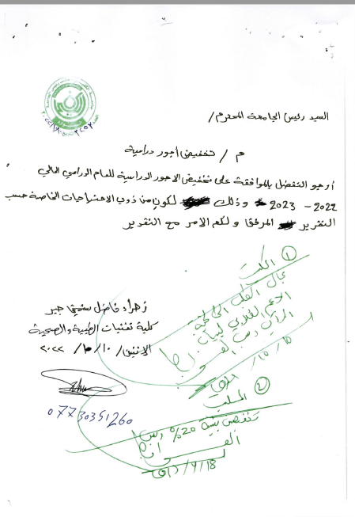

### Medical and Mental Health

The University of Alkafeel prioritizes the mental health and well-being of its students, offering free counseling services to help manage stress, anxiety, and other mental health issues. This support is especially beneficial for students facing financial hardships, as it enables them to focus on their academic goals without additional burdens.

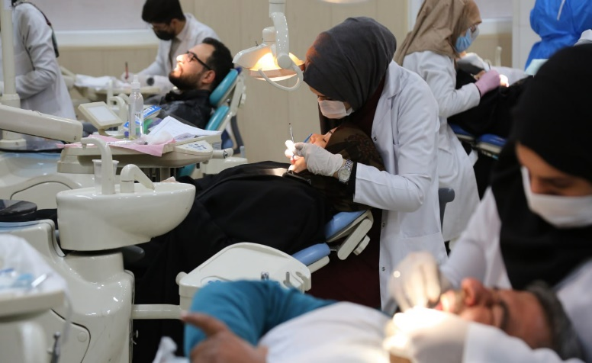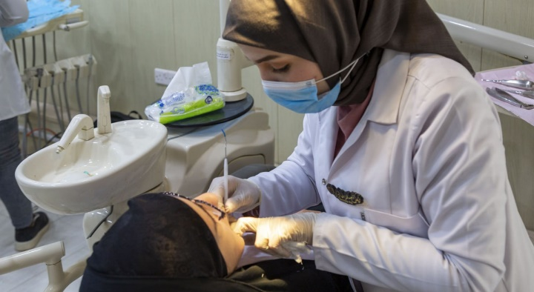

### C:\Users\hp\Desktop\تصنيفات\SDGs\صحة\photo_2024-10-22_12-10-49.jpg

Below are some of guiding unit activates for mental Health

|  |  |
| --- | --- |
| Pic | University order |
|  | **Community service activity**  Based on the authority granted to us in accordance with Law No. 25 of 2016, we have decided to conduct a community service activity to visit children suffering from leukemia at the Cancer and Tumor Center to provide financial support for these categories. The visit is scheduled for Wednesday, 29/11/2023, at 10:00 AM, with participation from the teaching staff and students of the College of Medicine, second-year students listed in the attached list. |
|  | **Student trip**  Based on the authority granted to us in accordance with Law No. 25 of 2016, we have decided to organize a trip to the Holy Shrines in Karbala for third-year students of the College of Pharmacy, whose names are listed in the attached list. This is to participate in some activities to promote moral values, accompanied by their academic advisors. The trip will take place on Wednesday, 29/11/2023.  1. Dr. Hussam Ali Hassan Al-Ubaidi  2. Mrs. Hanaa Nouri Ahmed  3. Mr. Mohamed Jabbar Obeid |
|  | **Student trip**  Based on the authority granted to us in accordance with Law No. 25 of 2016, we have decided to organize a recreational trip to the city of Nuwaira, the tourist destination in Karbala, for third- and fourth-year students of the College of Health and Medical Technologies / Department of Laboratory Analysis. The trip will take place on Friday, 1/12/2023, accompanied by teachers and academic advisors. |
|  | **Visit**  Based on the authority granted to us in accordance with Law No. 25 of 2016, we have decided to organize a visit to the "Hakayati" Center and provide both financial and moral support for orphans. The visit will be accompanied by a group of teaching staff and some students from the College of Health and Medical Technologies. This will take place on Tuesday, 26/12/2023. |
|  | **Student trip**  Based on the authority granted to us in accordance with Law No. 25 of 2016, we have decided to organize a recreational trip to the city of Nuwaira, the tourist destination in Karbala, for the students of the College of Health and Medical Technologies / Department of Radiology and Anesthesia. The trip will take place on Thursday, 14/12/2023, accompanied by teachers and academic advisors. |
|  | **Student trip**  Based on the authority granted to us in accordance with Law No. 25 of 2016, we have decided to organize a recreational trip to the city of Nuwaira, the tourist destination in Karbala, for the students of the College of Dentistry. The trip will take place on Thursday, 7/12/2023, accompanied by teachers and academic advisors. |
|  | **Seminar**  Based on the authority granted to us in accordance with Law No. 25 of 2016 (as amended), we have decided to hold a symposium on Quranic recitation in collaboration with the Holy Quran Institute in Najaf - The Scientific Society for the Holy Quran / The Holy Al-Abass Shrine. The symposium is titled "The Quranic Vision in the Importance of Veil and Modesty and Its Reflection in the Blessed Biography of Lady Zainab Al-Kubra (Peace Be Upon Her)" and will be held with the honorable guest Sheikh Zaman Sahib Mahdi on the occasion of the blessed birth anniversary of Lady Zainab (Peace Be Upon Her). The symposium will take place in the building of the College of Medicine at 10:00 AM on Monday, 20/11/2023. |
|  | **Forum**  Based on the authority granted to us in accordance with Law No. 25 of 2016 (as amended), we have decided to organize a session for memorization, recitation, and study of the Holy Quran for female students every Monday of each week throughout the academic year 2023-2024, during free student hours. This will be in cooperation with the Holy Quran Institute in Najaf - The Scientific Society for the Holy Quran / The Holy Al-Abass Shrine. |
|  | **Training forums**  Based on the authority granted to us in accordance with Law No. 25 of 2016 (as amended), we have decided to organize training forums for the development of the capabilities and skills of our students during free hours, according to the academic schedules of the colleges and scientific departments, for the academic year 2023-2024. This will be with the participation of the advanced coach Mr. Safaa Muhammad Jawad. |
|  | **Forum**  Based on the authority granted to us in accordance with Law No. 25 of 2016 (as amended), we have decided to organize a student drawing forum every Monday and Wednesday of each week during the academic year 2023-2024, during free student hours, with the participation of instructor Dr. Bahaa Swadi from the Department of Art Education at the College of Mixed Education, the University of Kufa. |
|  | **Community service**  Based on the authority granted to us in accordance with Law No. 25 of 2016 (as amended), we have decided to organize a community service campaign by hosting a group of orphans (35 children) in coordination with the `Aein Foundation for Social Care, to attend a ceremony at our university on the occasion of the Prophet’s Birthday on Tuesday, 3/10/2023, at 10:00 AM. The event will include providing them with a meal and some gifts, with participation from teachers, staff, and academic advisors, whose names are listed in the attached list. |
|  | **Ceremony**  Based on the authority granted to us in accordance with Law No. 25 of 2016 (as amended), we have decided to hold a ceremony on the occasion of the Prophet’s Birthday on Tuesday, 3/10/2021, at 10:00 AM, according to the program outlined in the attached schedule. |
|  | **Ceremony**  Based on the authority granted to us in accordance with Law No. 25 of 2016, we have decided to hold a ceremony to celebrate the birth of Lady Fatima Al-Zahra (peace be upon her) on Wednesday, 20th of Jumada al-Akhira, 1445 AH, corresponding to 3/1/2024. The event will also include an exhibition of artistic and handcrafted works for students. |

### Transportation and Essential Services

To ensure students can attend their classes without transportation challenges, the university provides free shuttle services across campus. This service is particularly valuable for students without personal vehicles. During the month of Ramadan, the university also organizes an annual iftar for students and offers food assistance through a "food basket" initiative, supporting students during this important time.

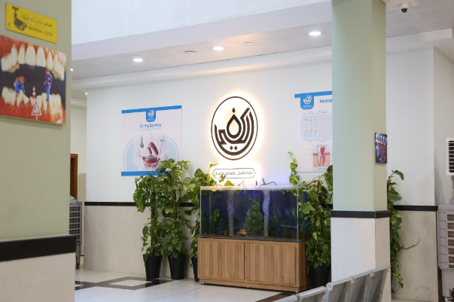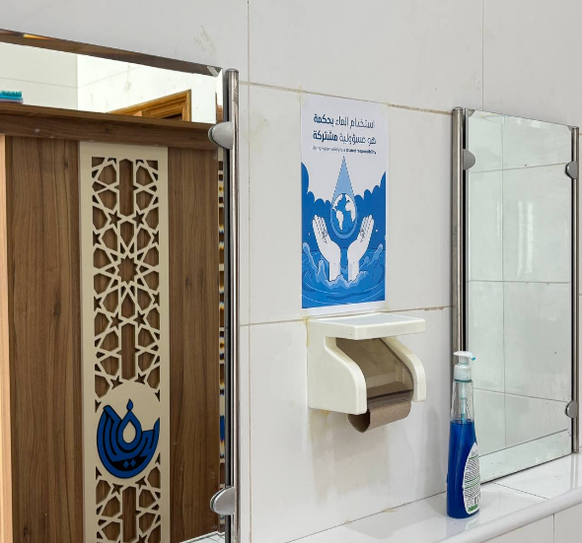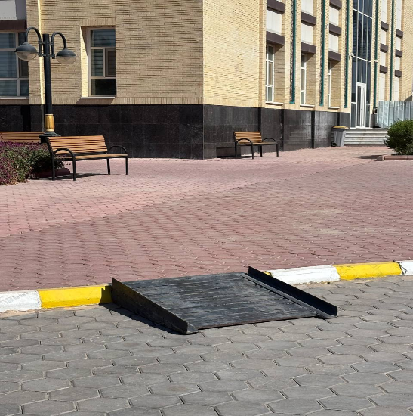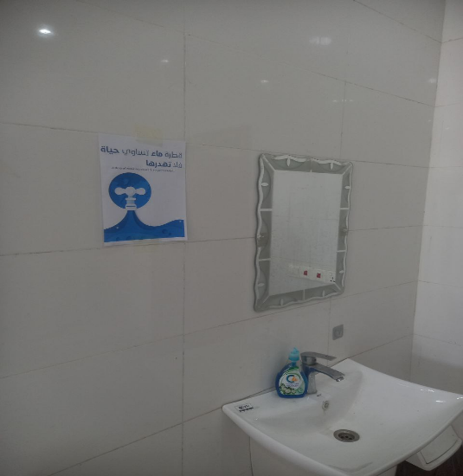

### C:\Users\hp\Desktop\تصنيفات\SDGs\فقر\photo_2023-07-08_10-45-02 (3).jpgC:\Users\hp\Desktop\تصنيفات\SDGs\فقر\photo_2023-07-08_10-51-08.jpg

### Housing and Legal Services

Additionally, the university is committed to addressing the housing needs of students from low-income families by facilitating access to affordable housing options. Legal counseling is available to help students navigate any challenges they may face during their time at university.

In conclusion, the University of AlKafeel is dedicated to offering comprehensive support to its low-income students. From academic and financial aid assistance to transportation, mental health services, and more, the university is committed to ensuring that all students, regardless of their financial circumstances, have the opportunity to succeed academically.

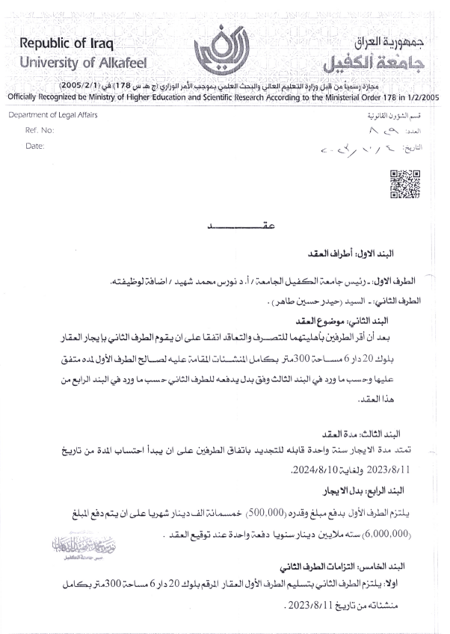

Lease contracts